**Waiver for import duties for construction materials**

* Following Hurricane Maria, the Government of Dominica has waived the following import duties on most construction materials for all commercial and non-commercial imports.
  + Import duties (varies between 5% - 30%),
  + Value Added Tax on imports (15%)
* The waiver is applicable for the following items:

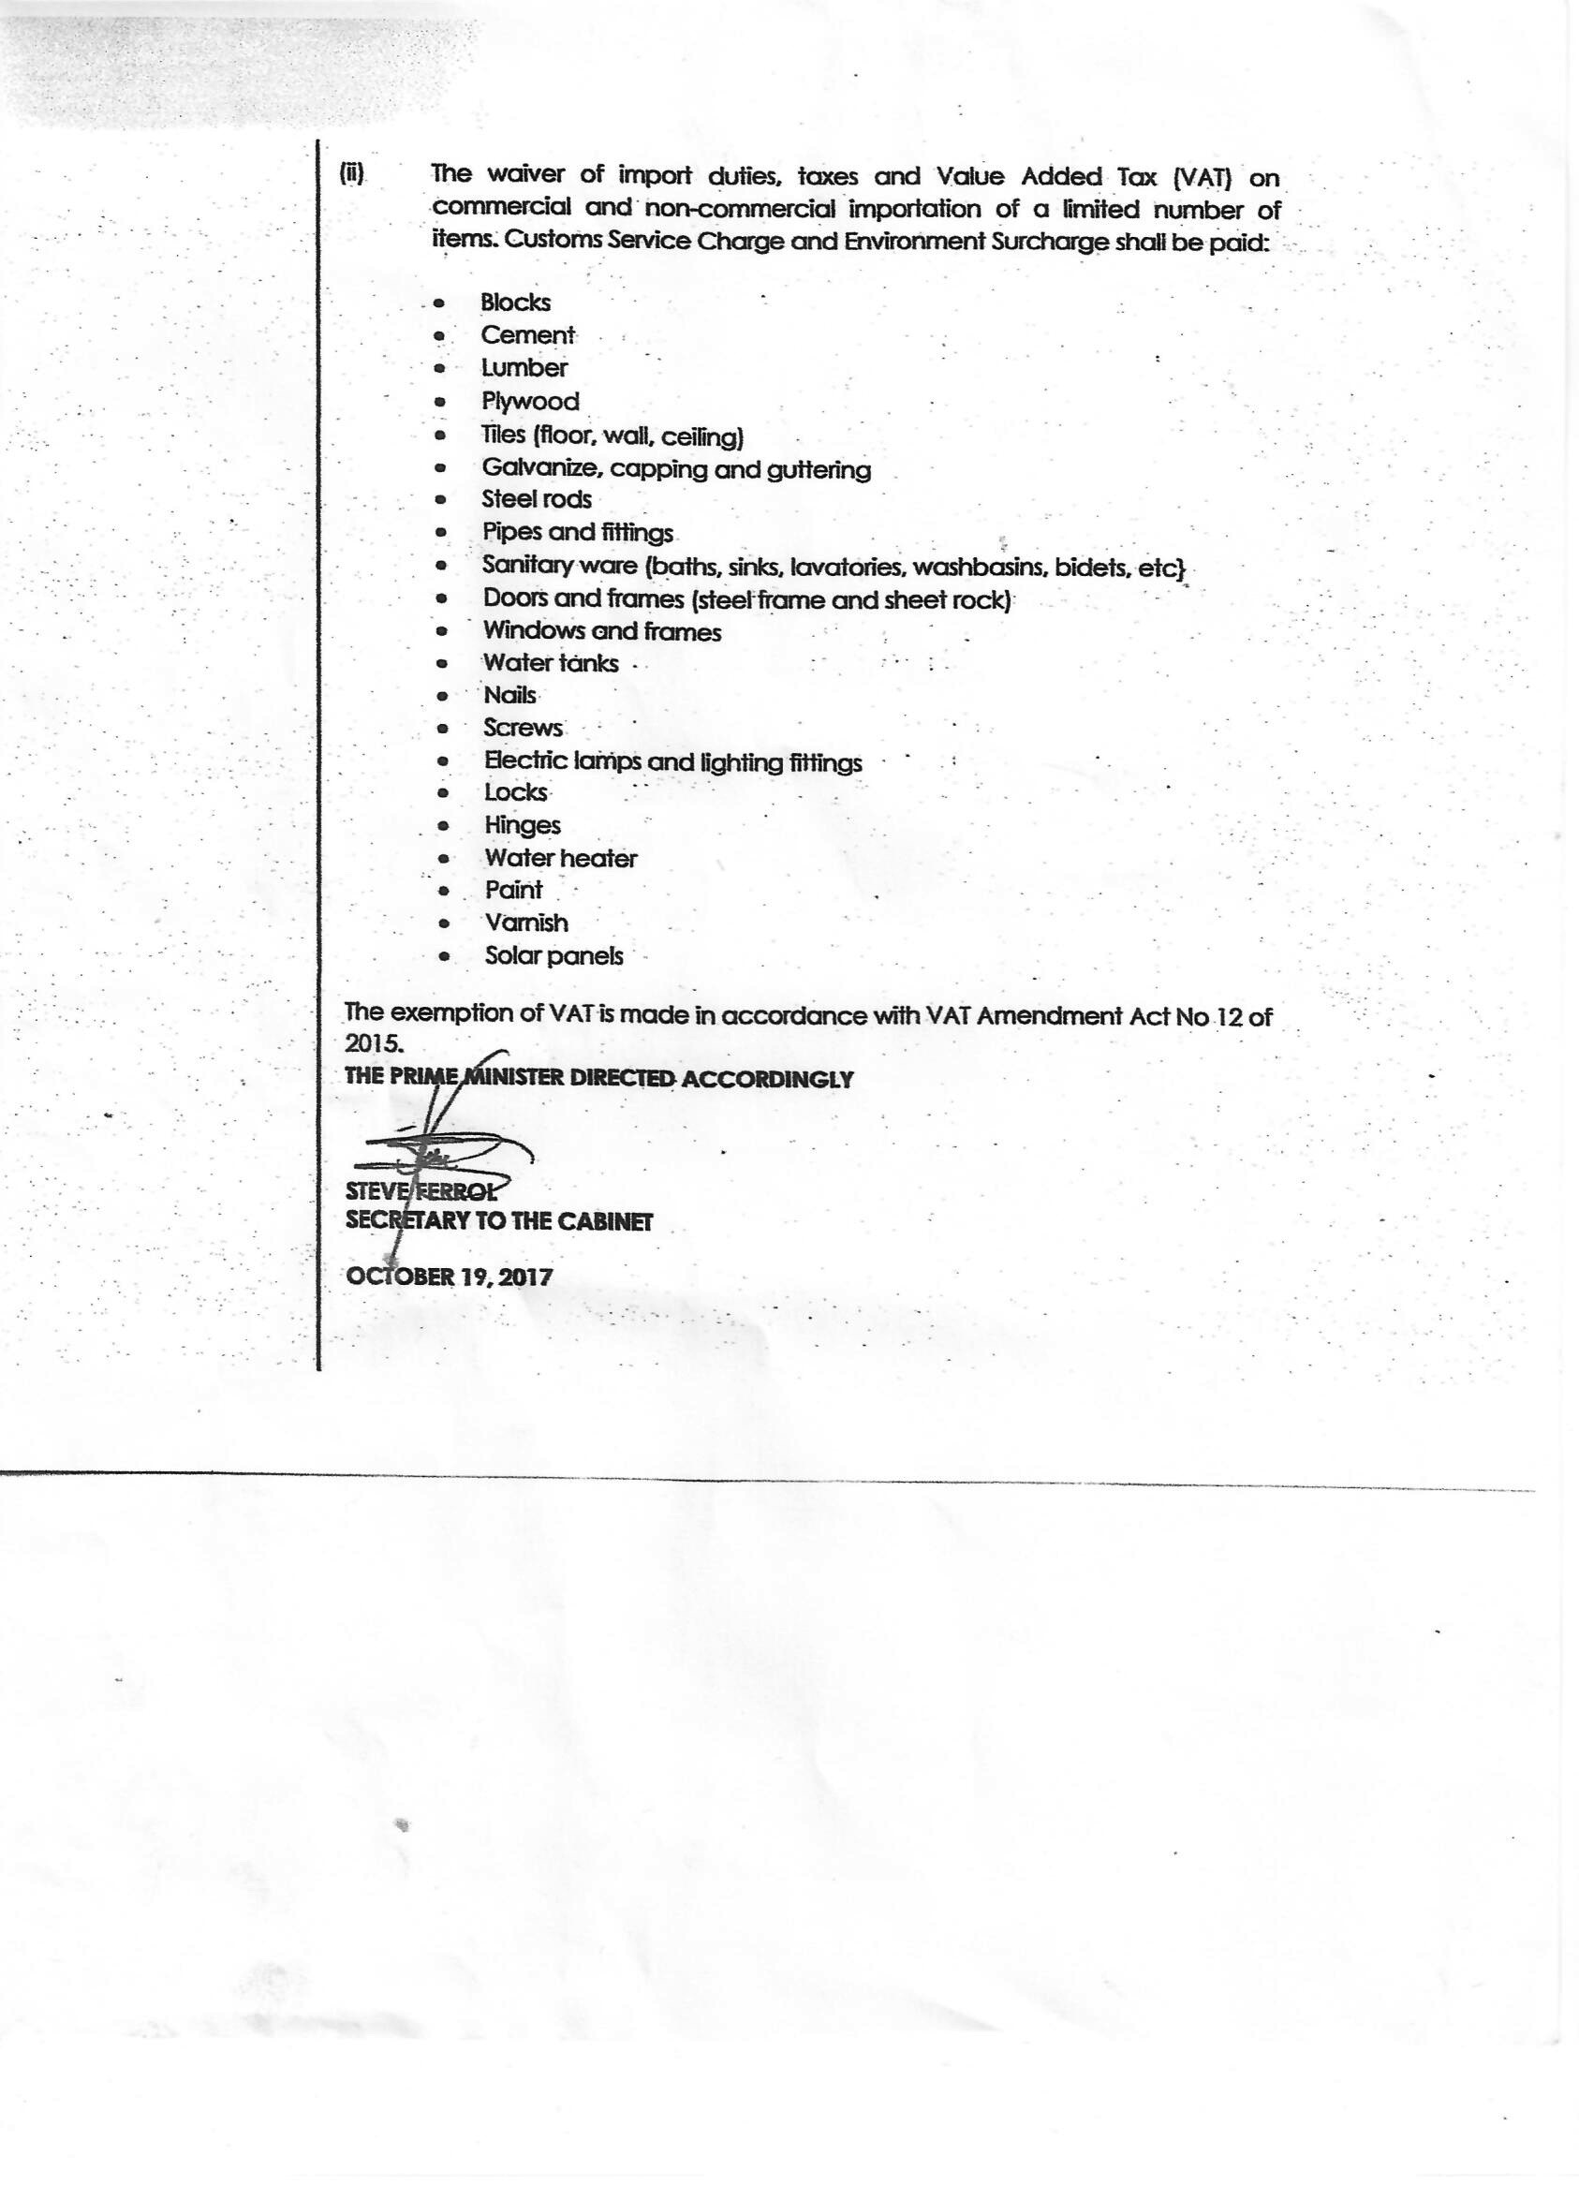

|  |  |  |  |  |
| --- | --- | --- | --- | --- |
| **Concession for commercial ad non-commercial imports in Dominica** | | | | |
|  | **Import duty** | **Environmental Surcharge** | **Customs Service Charge** | **Value Added Tax** |
| **NORMAL Times**  **(after 19-04-2018)**  ***During waiver period***  ***(19-10-2017 – 19-04-2018)*** | **Varies per product 5% to 30%** | **1.5%** | **4%** | **15%** |
| Regular commercial and non commercial imports | Applied  ***Waived*** | Applied  *Applied* | Applied  *Applied* | Applied  ***Waived*** |
| Donations to approved Chartable organizations | Waived  ***Waived*** | Waived  ***Waived*** | Waived  ***Waived*** | Waived  ***Waived*** |
| Purchase by charitable organizations | Waived  ***Waived*** | Applied  *Applied* | Applied  *Applied* | Applied  ***Waived*** |
| Imports by diplomats or regional and International Organisations | Waived  ***Waived*** | Waived  ***Waived*** | Waived  ***Waived*** | Waived  ***Waived*** |

* The waiver period started on 19-10-2017 and will be valid for 6 months till 19-04-2018
* For more information about import duties in Dominica contact: [Nandalawrence@hotmail.com](mailto:Nandalawrence@hotmail.com) from the ministry of Finance.