

## Situation Update 8 – WESTERN DIVISION FLOODS

*Prepared: 1800hrs Thursday 16th April, 2012*

**TO**: DISTRIBUTION

**KEY UPDATES:**

* Replenishing stocks in the West branches
* Distribution of relief items
* UNFPA to supply FRCS with Dignity Packs by Wednesday 18/04

**SITUATIONAL OVERVIEW**

FRCS Western branches flood operations are continuing with their distributions of relief supplies on both the Disaster and Health items. Relief items from Australian Red Cross have been received and distributions are ongoing together with FRCS existing stocks. Replenishment on our NFI items is an ongoing activity for our logistics team as packing of more hygiene packs will resume on Wednesday. UNFPA will be supplying Fiji Red Cross with the first batch of 1000 Dignity Kits which will be distributed alongside our relief items that have been supplied to the affected areas so far.

**WEATHER OVERVIEW**

A trough of low pressure with associated cloud and rain remains over Fiji. It is expected to gradually weaken and move eastwards away from the Fiji group tomorrow.

**Satellite Image**

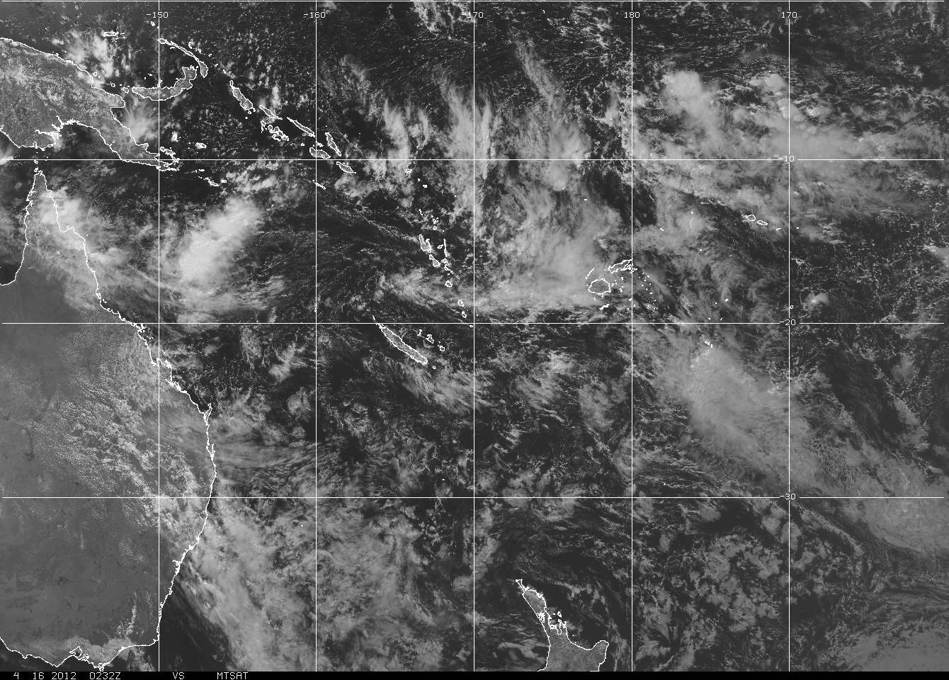

**ASSESSMENTS AND distribution**

Assessments and distribution are continuing together with the new kits that were donated by Australian Red Cross. Hygiene kits received from ARC have been supplied to the priority affected areas and have been part of the relief items distributed to the affected families

The National Office team with the full support from the office of the Commissioner Central, were able to travel to assist the affected during the flood in the Central Division. Areas that were assessed and assisted were areas along the Rewa Delta and the villages in Toga. The affected families were assisted with Black packs, Hygiene Kits, WASH Kits, Cooking Set and Blankets

**HEALTH**

The major health risk that our teams on the ground are supporting the Ministry of Health with is water and sanitation. Assessments from the team have also stated that there is a risk for people going back to their homes when it is still not safe. The Health Officer in Nadi have voiced their concern about WATSAN and FRCS Health team are supplying these areas with hygiene kits, WASH kits and also advocating on these health issues. The FRCS Health teams on the ground have been working closely with the District Health representative in this regard. The teams are also looking into the evacuation centers that are still operational in Sigatoka and in Nadi as these healths issue is a critical matter in these affected areas

**DISTRIBUTION DETAILS**

Please find distribution details attached as Annex 1

**INTERNATIONAL SUPPORT**

Australian Red Cross Hygiene Kits have been distributed with our current relief items that are distributed to the affected families. More relief items are still yet to be received and will all be in the country by the end of this week.

**OPERATIONS FOR NEXT 24 HOURS**

FRCS intends to conduct the following activities over the next 24 hours:

* + Packing and Dispatch of relief items to DP Containers from National Office
  + Continue with Initial Damage Assessments and Distribution of Relief supplies
  + Reporting updates from West branches on daily assessments and distribution details
  + Continue liaising with partners

**RecommendationS**

1. Continue monitoring status and coordinate where necessary.

**END.**

Fiji Red Cross Society

*National Office, 22 Gorrie Street, GPO Box 569, Suva FIJI ISLANDS*

Phone: + 679 331 4133 or + 679 331 4138

Mobile: + 679 999 2481 Fax: + 679 330 3818

Email: [redcross@connect.com.fj](mailto:redcross@connect.com.fj)

ESEROMA LEDUA (Disaster Coordinator)

#### FOR DIRECTOR GENERAL

**For media information – Christopher Ho: + 679 999 2481**

*[FRCS will issue numbered SITUATION REPORTS daily or twice a day if necessary depending on intensity of imminent threat, damage and scale of operations]*

**Annex 1:**

|  |  |  |  |  |  |  |  |  |  |  |
| --- | --- | --- | --- | --- | --- | --- | --- | --- | --- | --- |
| **Current Response** |  |  |  |  |  |  |  |  |  |  |
|  |  |  |  |  |  |  |  |  |  |  |
| Sum of Black Pack |  |  | Sum of Cooking Set |  |  | Sum of Water Container |  |  | Sum of Baby Pack |  |
| Branch | Total |  | Branch | Total |  | Branch | Total |  | Branch | Total |
| Nadi | 430 |  | Nadi | 54 |  | Nadi | 161 |  | Nadi |  |
| Sigatoka | 252 |  | Sigatoka | 16 |  | Sigatoka | 13 |  | Sigatoka | 1 |
| Tavua | 53 |  | Tavua | 36 |  | Tavua | 0 |  | Tavua | 0 |
| (blank) |  |  | (blank) |  |  | (blank) |  |  | (blank) |  |
| Ba | 190 |  | Ba | 39 |  | Ba | 10 |  | Ba | 0 |
| Rakiraki | 97 |  | Rakiraki |  |  | Rakiraki |  |  | Rakiraki |  |
| Lautoka | 153 |  | Lautoka | 14 |  | Lautoka |  |  | Lautoka |  |
| Grand Total | 1175 |  | Grand Total | 159 |  | Grand Total | 184 |  | Grand Total | 1 |
|  |  |  |  |  |  |  |  |  |  |  |
|  |  |  |  |  |  |  |  |  |  |  |
| Sum of Blankets |  |  | Sum of Tarpauline |  |  | Sum of Hygience Pack |  |  | Sum of Dignity Pack |  |
| Branch | Total |  | Branch | Total |  | Branch | Total |  | Branch | Total |
| Nadi | 496 |  | Nadi | 2 |  | Nadi | 635 |  | Nadi |  |
| Sigatoka | 22 |  | Sigatoka | 44 |  | Sigatoka | 91 |  | Sigatoka | 3 |
| Tavua | 26 |  | Tavua | 16 |  | Tavua | 46 |  | Tavua |  |
| (blank) |  |  | (blank) |  |  | (blank) |  |  | (blank) |  |
| Ba | 181 |  | Ba |  |  | Ba | 262 |  | Ba |  |
| Rakiraki |  |  | Rakiraki | 11 |  | Rakiraki | 97 |  | Rakiraki |  |
| Lautoka | 71 |  | Lautoka | 25 |  | Lautoka | 20 |  | Lautoka |  |
| Grand Total | 796 |  | Grand Total | 98 |  | Grand Total | 1151 |  | Grand Total | 3 |
|  |  |  |  |  |  |  |  |  |  |  |
|  |  |  |  |  |  |  |  |  |  |  |
|  |  |  |  |  |  |  |  |  |  |  |
| Sum of Wash Kit |  |  | Sum of First Aid Kit |  |  | Sum of Daipers |  |  | Sum of Gas Stove |  |
| Branch | Total |  | Branch | Total |  | Branch | Total |  | Branch | Total |
| Nadi | 448 |  | Nadi |  |  | Nadi | 28 |  | Nadi |  |
| Sigatoka | 136 |  | Sigatoka | 7 |  | Sigatoka |  |  | Sigatoka | 2 |
| Tavua | 46 |  | Tavua |  |  | Tavua |  |  | Tavua |  |
| (blank) |  |  | (blank) |  |  | (blank) |  |  | (blank) |  |
| Ba | 234 |  | Ba | 2 |  | Ba | 10 |  | Ba |  |
| Rakiraki | 97 |  | Rakiraki |  |  | Rakiraki |  |  | Rakiraki |  |
| Lautoka | 147 |  | Lautoka |  |  | Lautoka |  |  | Lautoka |  |
| Grand Total | 1108 |  | Grand Total | 9 |  | Grand Total | 38 |  | Grand Total | 2 |
|  |  |  |  |  |  |  |  |  |  |  |
|  |  |  |  |  |  |  |  |  |  |  |
|  |  |  |  |  |  |  |  |  |  |  |
| Sum of No Of Families |  |  | Sum of Total People |  |  |  |  |  |  |  |
| Branch | Total |  | Branch | Total |  |  |  |  |  |  |
| Nadi | 1857 |  | Nadi | 6495 |  |  |  |  |  |  |
| Sigatoka | 757 |  | Sigatoka | 2444 |  |  |  |  |  |  |
| Tavua | 121 |  | Tavua | 507 |  |  |  |  |  |  |
| Ba | 390 |  | Ba | 1822 |  |  |  |  |  |  |
| Rakiraki | 102 |  | Rakiraki | 431 |  |  |  |  |  |  |
| (blank) |  |  | (blank) |  |  |  |  |  |  |  |
| Lautoka | 315 |  | Lautoka | 373 |  |  |  |  |  |  |
| Grand Total | 3542 |  | Grand Total | 1202 |  |  |  |  |  |  |